- TITLE: SIMPLE REFLEX AGENT FOR PARTICLE PICKING PROBLEM
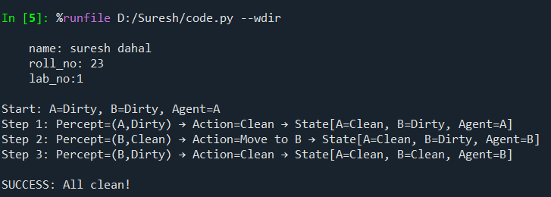

- TITLE: UTILITY-BASED AGENT FOR SIMPLE WUMPUS WORLD
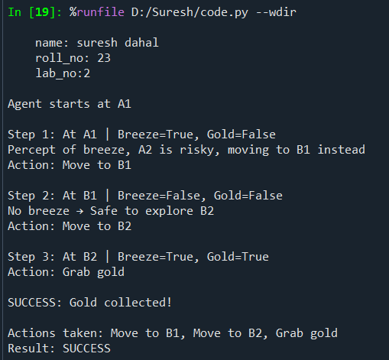

- TITLE: GOAL-BASED AGENT FOR SIMPLE WUMPUS WORLD
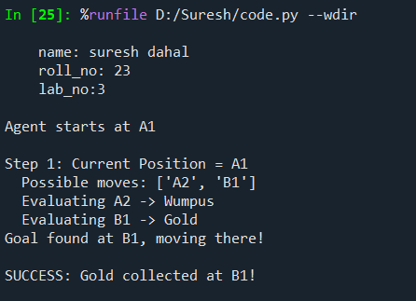

- TITLE: MODEL-BASED AGENT IN A SIMPLE WUMPUS WORLD
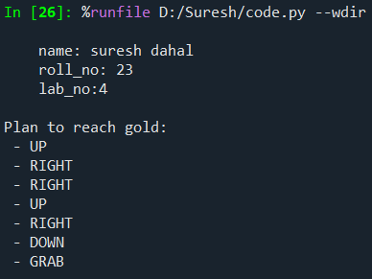

- TITLE: SOLVING 8-PUZZLE USING BFS ALGORITHM
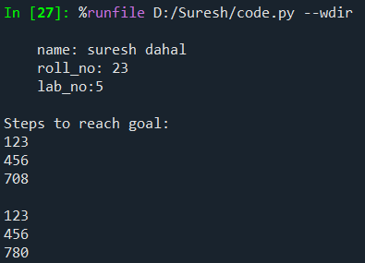
- TITLE: SOLVING 8-PUZZLE USING DFS ALGORITHM
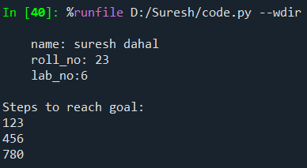

- TITLE: SOLVING 8-PUZZLE USING ITERATIVE DEEPENING DFS
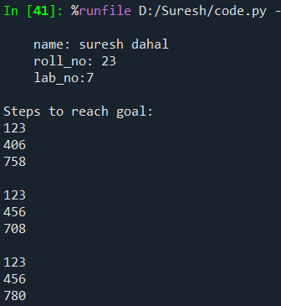
- TITLE: PATH PROBLEM SOLUTION USING BEST FIRST SEARCH
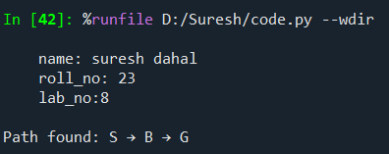

- TITLE: PATH PROBLEM SOLUTION USING A* SEARCH
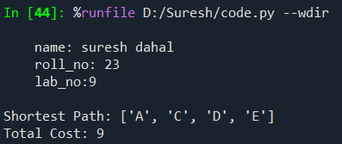

- TITLE: BLOCK WORLD USING HILL CLIMBING SEARCH
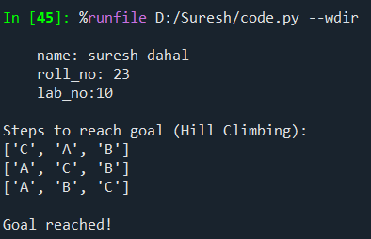

- TITLE: AND GATE USING HEBBIAN NEURAL NETWORK
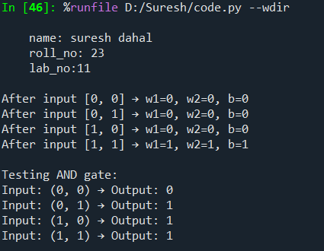

- TITLE: AND GATE USING PERCEPTRON NEURAL NETWORK
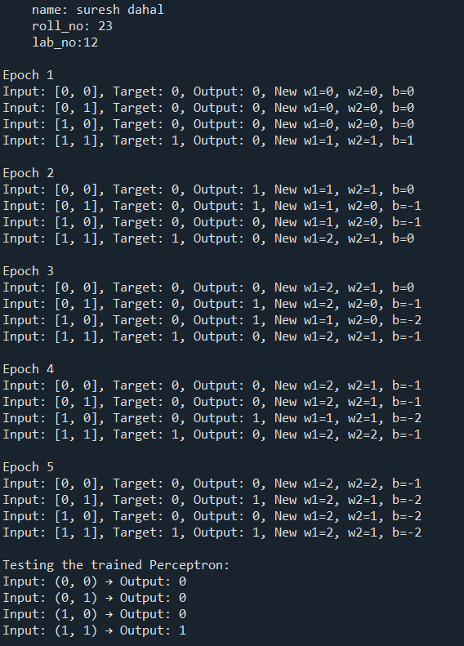

- TITLE: BACKPROPAGATION NEURAL NETWORK TRAINING ALGORITHM
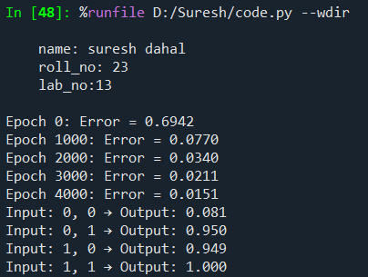
- TITLE: GENETIC ALGORITHM IMPLEMENTATION
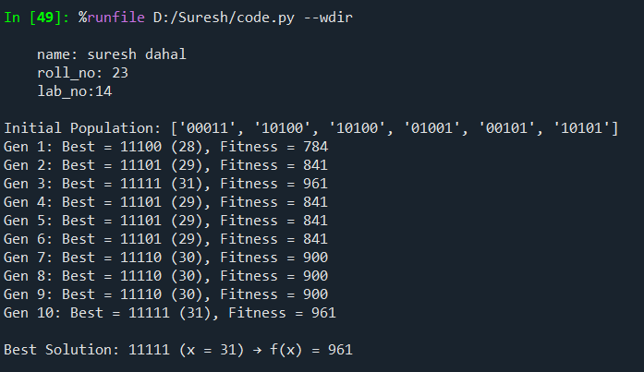

- TITLE: SPAM DETECTION USING NAIVE BAYES CLASSIFIER
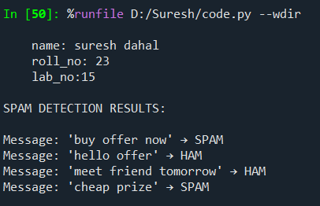

- TITLE: PARSE TREE GENERATION OF A SENTENCE
